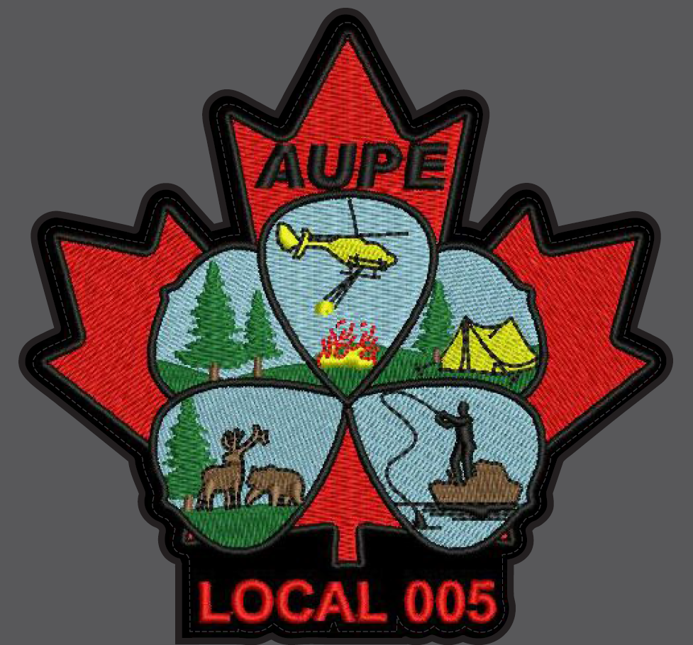

Welcome to AUPE Local 005

Who is Local 005:
Natural Resources and Conservation Services represent employees of the Government of Alberta who work to preserve, protect, and manage our natural forests, mountains, lakes, rivers, foothills and prairie landscapes, fish and wildlife species as well as the flora and fauna. It is made up of members from the following Divisions: Forestry, Lands, Fish and Wildlife, Wildfire and Conservation.

The Local Executive is made up of elected members from around the Province (provincial contacts):
Position | Name | Email
Chair | Aaron Townsend | Email Local 005 Chair
Vice-Chair | Samantha Davies | Email Local 005 Vice-Chair
Secretary | Shawna Lund | Email Local 005 Secretary
Treasurer | Crystal Ionson | Email Local 005 Treasurer
PE Representative | Rick Harrison | Email Local 005 PE Rep
Alt.1 PE Representative | Kari Matechuk | Email Alt. 1 Local 005 PE Rep
Alt. 2 PE Representative | TBD
OH&S Representative | Chris Joly | Email Local 005 OHS Rep
Alt. OH&S Representative | Nicole Braun | Email Alt. Local 005 OHS Rep
Webmaster | Rick Harrison | Email Local 005 Webmaster
Our Local is divided into 10 geographical chapters to ensure each regions needs are represented by the Local as a whole. They are as follows:
CHAPTERS
01 - Calgary area (Airdrie, Calgary, Canmore, Cochrane, Drumheller, High River, Kananaskis Country, Okotoks, Peter Lougheed Provincial Park and Seebe).

02 - Edmonton area (Barrhead, Edmonton, Fort Saskatchewan, Leduc, Morinville, Sherwood Park, Spruce Grove, St. Albert, and Stony Plain).

03 – Ft. McMurray (Ft Chipewyan, Ft Mackay, Ft Mc Murray).

04 – High Level (Ft Vermilion, High Level, Rainbow Lake).

05 – Peace River area (Fairview, Peace River, Manning).

06 – Slave Lake (Slave Lake, High Prairie, Wabasca).

07 – Grande Prairie (Grande Prairie, McLennan, Valleyview).

08 – Lac La Biche (Athabasca, Bonnyville, Grande Centre, Lac La Biche, Smoky Lake,
St. Paul, and Vermillion).

10 – Whitecourt (Fox Creek, Swan Hill, Whitecourt).

11 – Edson (Edson, Hinton, Grande Cache).

12 – Rocky Mountain House (Drayton Valley, Rocky Mountain House).

13 – Red Deer (Red Deer).
15 – Blairmore (Crowsnest Pass (Bellevue, Blairmore, Coleman, Frank, Hill Crest) Pincher Creek, Medicine Hat).

Each of these Chapters have their own Chapter Executive (regional contacts):

Chapter 1 - Calgary  Chair Chris Joly  Vice-Chair Nathan Brown  Secretary Kai Lauridsen  Treasurer Kai Lauridsen | Chapter 8 - Lac La Biche  Chair Clifton McKay  Vice-Chair Mike Tucker  Secretary Jason Hebert  Treasurer Jason Hebert
Chapter 2 - Edmonton  Chair Cosmin Tansanu  Vice-Chair Cosmin Tansanu  Secretary Cosmin Tansanu  Treasurer Cosmin Tansanu | Chapter 10 - Whitecourt  Chair Dave Geddes  Vice-Chair Brian Lopushinsky  Secretary Allison Brown  Treasurer Fauve Blanchard
Chapter 3 - Ft McMurray  Chair Scott Johnston  Vice-Chair Rob Barnett  Secretary Kent Jennings  Treasurer Paul St John | Chapter 11 - Edson  Chair Tanya Sawicki  Vice-Chair Ben Biro  Secretary Denise Bath  Treasurer Denise Bath
Chapter 4 - High Level  Chair Sam Davies  Vice-Chair Jason Smith  Secretary Stephanie Niemiec  Treasurer Stephanie Niemiec | Chapter 12 - Rocky Mountain House  Chair Aaron Townsend  Vice-Chair Wayne Werstiuk  Secretary Andrew Butler  Treasurer Andrew Butler
Chapter 5 - Peace River  Chair Lee Ruthven  Vice-Chair Gary Thirnbeck  Secretary Mike Lutz  Treasurer Mike Lutz | Chapter 13 - Red Deer  Chair Christopher Kelly  Vice-Chair Darren McInnes  Secretary Jordan Baier  Treasurer TBD
Chapter 6 - Slave Lake  Chair Crystal Ionson  Vice-Chair Craig McCormick  Secretary Deanna Zelt  Treasurer Shawna Lund | Chapter 15 - Blairmore  Chair Michael Taje  Vice-Chair Jordan Nelson  Secretary Peter Dunbar  Treasurer Peter Dunbar
Chapter 7 - Grande Prairie
Chair Kari Matechuk
Vice-Chair Tyler Pinnock
Secretary Jason Handfield
Treasurer Jason Handfield

Last update: February 25, 2020

Each chapter typically hosts events and meetings throughout the year to support and engage the membership.
To get involved and learn more about Local 005 or your Union in general go to the following websites:
Local 005 : http://aupe5.org/
AUPE (main) : https://www.aupe.org/

